Week-3: Configuration of basic switch setup using Huawei/Cisco network switch using cisco packet tracer.

Step 1: Add one switch & two pcs to switch connect the switch to pcs with using copper straight Through cable pcs to the switch using the fast Ethernet ports.

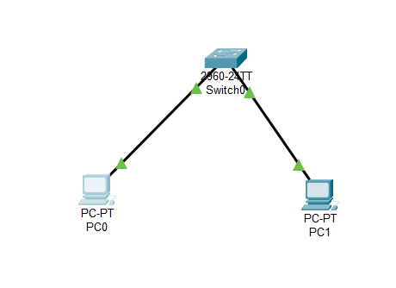

Step 2: Configuring the switch

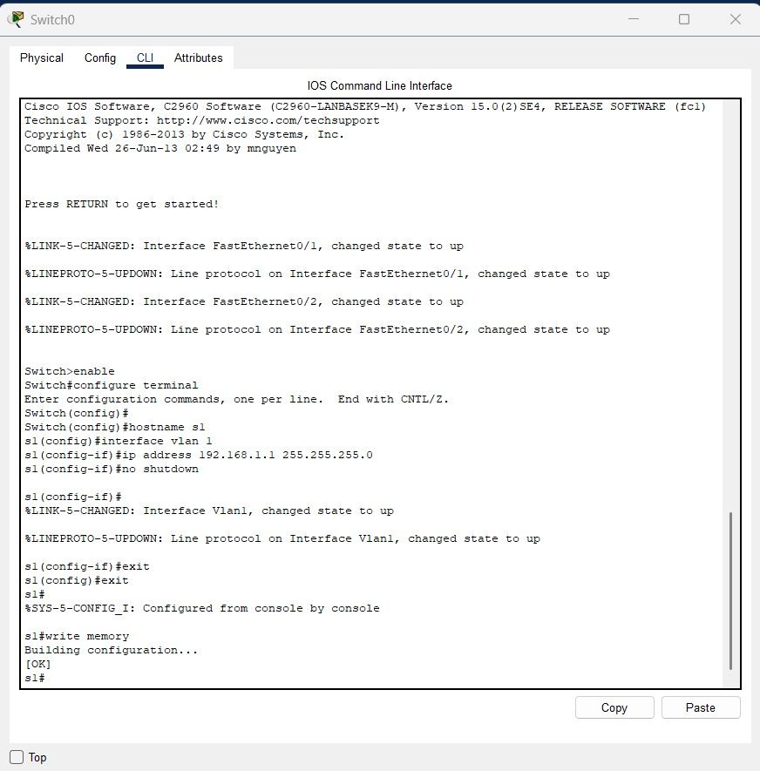

Step 3: Configuring pcs

Of pc0

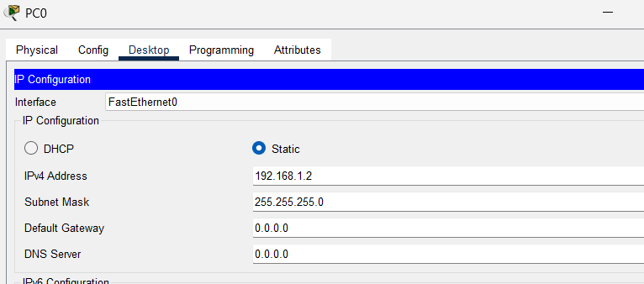

Of pc1

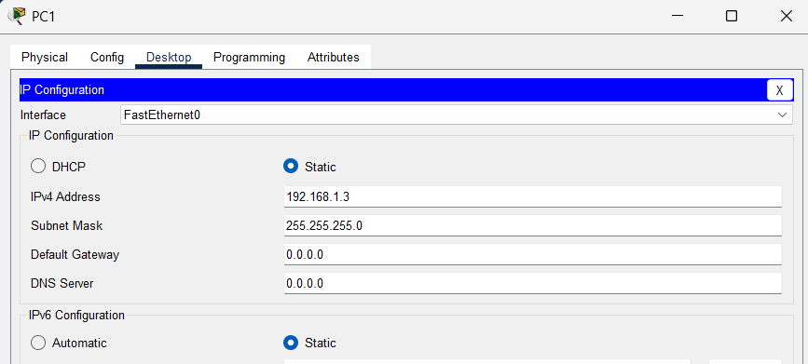

Step 4: Testing connectivity

